Identity
- A user with a username and password.
- Also applications or other servers with secret keys or certificates.
- The fact of being something or someone.

Authentication
The process of verification/assertion of identity
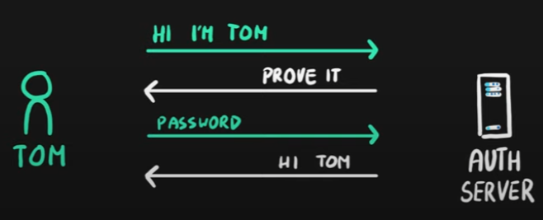

Authorization
The process of ensuring that only authenticated identities get access to the resources for which they have been granted access.
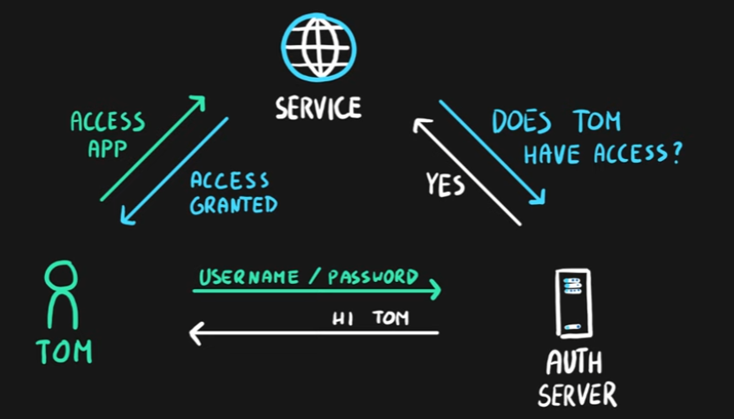

Access Management
The process of controlling, verifying, tracking and managing access to authorized users and applications.

Azure Active Directory
- Identity and Access Management service in Azure
- Identities management – users, groups, applications
- Access management – subscriptions, resource groups, roles, role assignments, authentication & authorization settings, etc.
- Used by multiple Microsoft cloud platforms
  - Azure
  - Microsoft 365
  - Office 365
  - Live.com services (Skype, OneDrive, etc.)
- Syncs with on-premises Active Directory via sync services
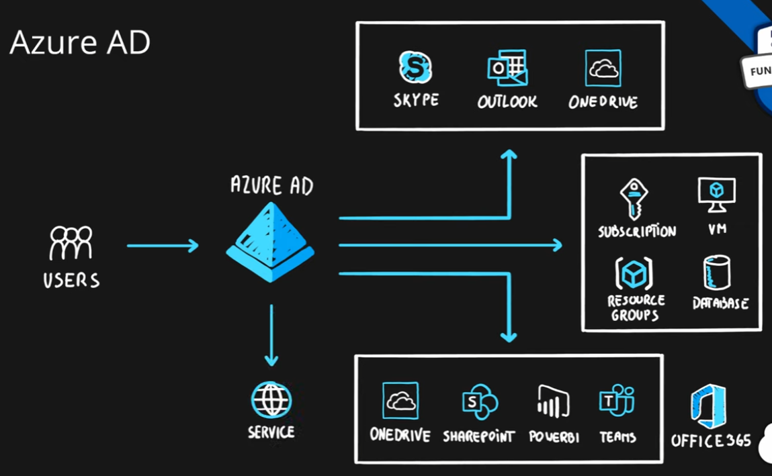

Multi-factor Authentication (MFA)
- Process of authentication using more than one factor (evidence) to prove identity
- Factor types
  - Knowledge Factor – “Something you know”, ex. password, pin
  - Possession Factor – “Something you have”, ex. phone, token, card, key
  - Physical Characteristic Factor – “Something you are”, ex. fingerprint, voice, face, eye iris
  - Location Factor – “Somewhere you are”, ex. GPS location
- Supported by Azure AD by default (simple on-off switch)
